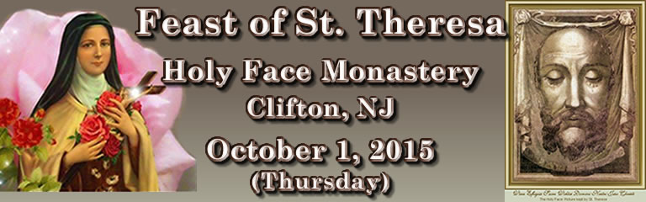
- 7:30 AM Holy Mass
P
A
X
- 8:00 AM Exposition of The Most Blessed
Sacrament (all day)

- 2:00 PM
5:00 PM Confessions

- 4:30 PM Pray the Rosary with St. Theresa

- 7:30 PM Holy Mass
Procession
Fellowship in AB. Gregori Hall
Roses will be distributed in honor
of St. Theresa

- Candles available all day. These will be
blessed during Holy Mass.

Through the intercession of St. Theresa, may we all
come to serve God with love, simplicity, and joy!
__________________________________________________

“He who has Jesus, has everything” (St. Theresa of
the Child Jesus)

